Experiment -3

Configure the DHCP server and wireless router and check the connectivity
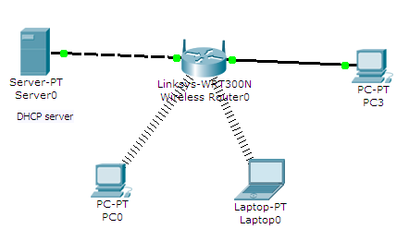

Step1 :configure the DHCP server

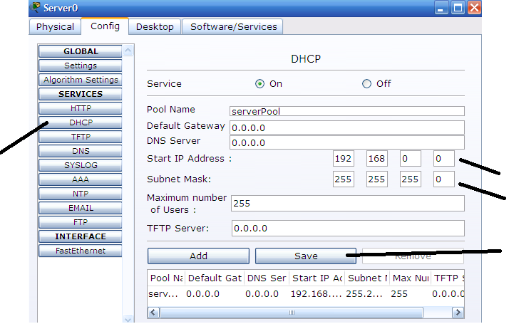

Step2: In server configure the fast Ethernet

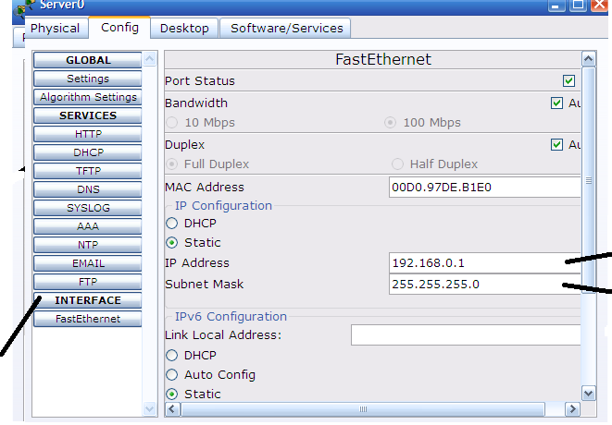

Step 3: configuare the wireless router

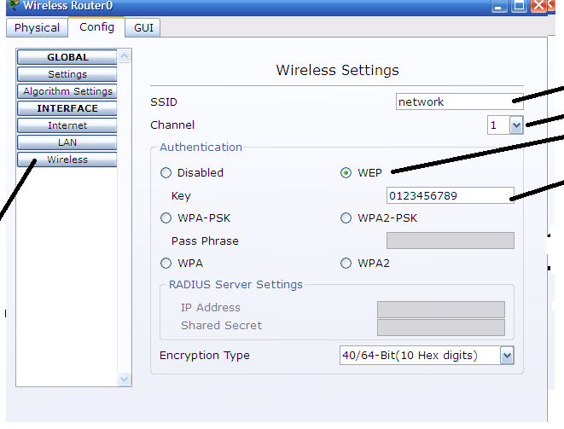

Step4 :Laptop remove the wired NIC card to wireless card

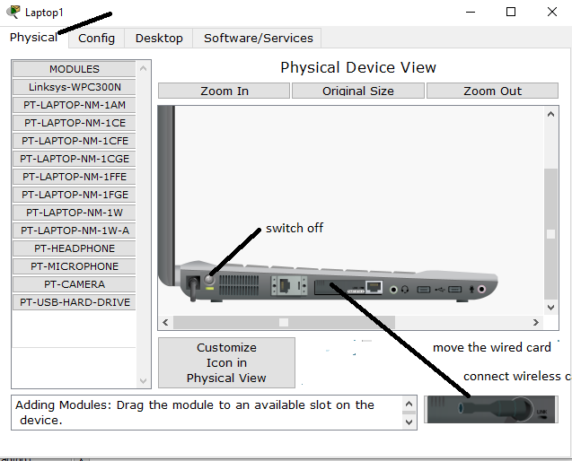

Step 5: Laptop connect the wireless

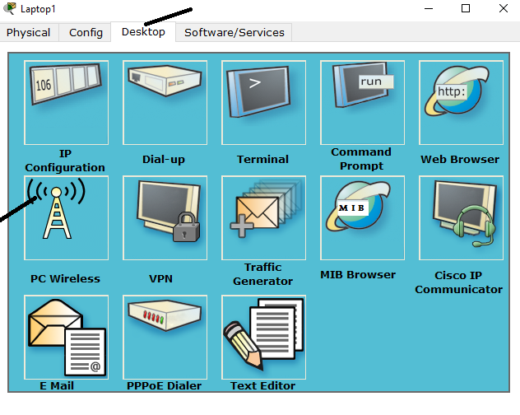

Step 6 : connect Laptop with wireless router

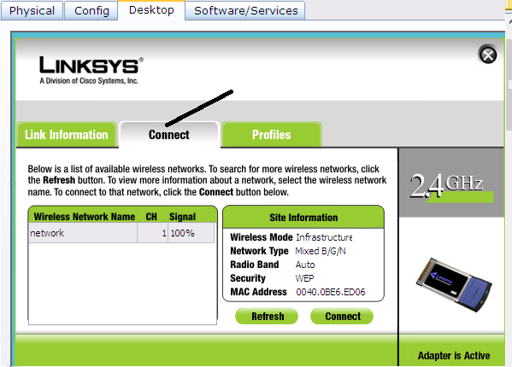

Step 7 :enter web key

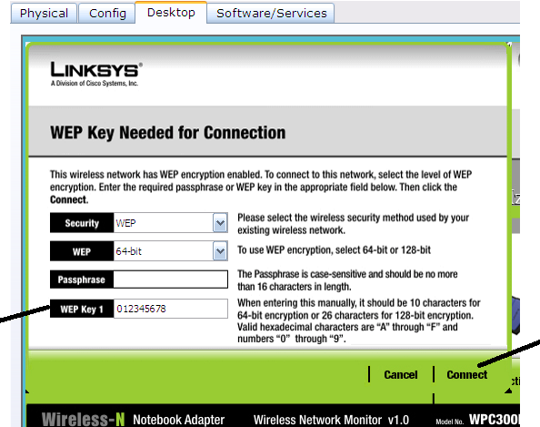

Step8 : PC remove the wired NIC card to wireless card

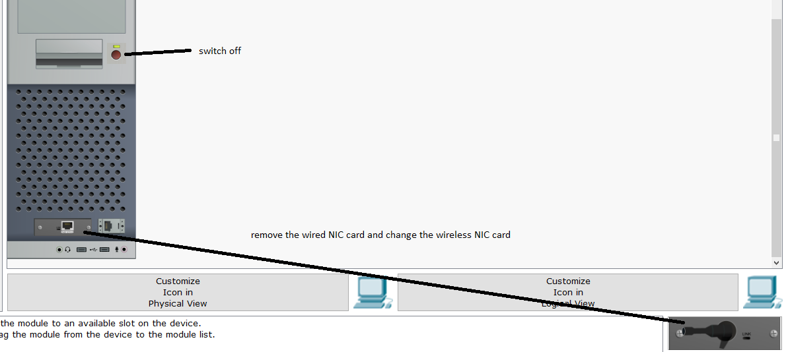

Note : Same steps 5,6,7

Step 9 : check the Pc and laptop for the DHCP ip address

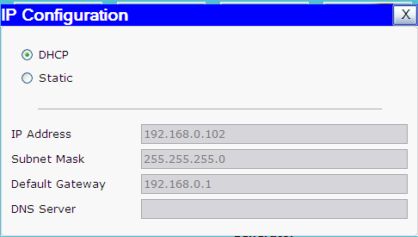

Step10 check the connectivity

